Digital Ethics and the Illusion of Freedom: Chomsky’s Challenge

Readings: Manufacturing Consent
Lecture: Propaganda and a Broken World
Branch: Media Ethics

Big Lecture Themes Today
1. Manufactured Consent and the Myth of Freedom
Chomsky argues that what we believe to be a free and rational society is, in reality, shaped by powerful media systems that filter information in ways that serve elite interests. This illusion of autonomy makes us more vulnerable to manipulation—especially in the digital age, where targeted content and algorithmic control replace open inquiry.

2. The Five Filters of Media Control
Chomsky and Herman’s five filters (ownership, advertising, sourcing, flak, anti-communist dichotomy) reveal how news is shaped by capital and ideology rather than truth. In today’s digital environment, these filters persist and have evolved: algorithms, surveillance capitalism, AI-generated news, cancel culture, and echo chambers now play these roles.

3. Digital Ethics and the Illusion of Choice
Chomsky reframes digital consent as an illusion. What appears to be free, informed participation in digital life is often just behavioral manipulation—customized news feeds, emotional targeting, and algorithmic steering that narrow our perception and reinforce dominant ideologies.

4. Media Silence and Ethical Double Standards
A key case study contrasts two genocides: the well-publicized Cambodian atrocities under Pol Pot vs. the neglected genocide in East Timor (supported by Western powers). Chomsky shows how media selectively reports based on political and economic interests—not moral urgency—exposing systematic bias and ethical failures.

5. The Ethical Challenge for Digital Citizens
In the digital age, ethics must move beyond individual responsibility to systemic awareness. Chomsky challenges us to ask: What am I not seeing? Who benefits from what I believe? What filters shape my reality? True freedom demands not just critical thinking—but critical awareness of the systems that frame our thinking.

How Does Manufacturing Consent Relate to Ethics in the Digital Age

1. Media Manipulation Is Structural, Not Accidental
Chomsky’s core claim is that media functions through systemic filters—such as corporate ownership, advertising pressure, and elite sources—that pre-structure the flow of information. In the digital age, these filters have been amplified by algorithmic curation and platform gatekeeping (e.g., Google, Meta), reinforcing concerns that “free” online information is not free of ideological control.

2. Consent Is Manufactured, Not Earned
The digital public believes it is making informed, autonomous decisions. But Chomsky warns that the very mechanisms that deliver content—search engines, newsfeeds, recommendations—are themselves ideological tools, subtly steering perception. This challenges ethical assumptions about digital autonomy, informed consent, and user empowerment.

3. Surveillance Capitalism Reinforces the Filters
Though not mentioned directly, Chomsky’s critique of advertiser influence anticipates the logic of surveillance capitalism. If data harvesting fuels profitability, then truth and public good are subordinated to profit and control—an ethical red flag in today’s platform economy where manipulation becomes personalized and invisible.

4. Dissent Is Marginalized, Not Debated
Chomsky emphasizes how elite-approved viewpoints are amplified, while dissenting voices are excluded or ridiculed. In digital ethics, this translates into algorithmic silencing, shadow banning, and content demotion—raising serious concerns about freedom of expression, pluralism, and the ethics of content moderation.

5. Digital Technologies Entrench Ideology Under the Guise of Neutrality
Perhaps most chillingly, Chomsky shows that ideology is most effective when it appears as “common sense” or neutrality. In the digital realm, this is echoed in platform claims of being “just a tool” or “just a mirror,” despite their active role in shaping public consciousness, reinforcing inequality, and obscuring accountability.

The Myth of a Free and Rational Society
In Manufacturing Consent, Noam Chomsky (with co-author Edward S. Herman) exposed how mass media in the United States—and by extension, other “free” democracies—serve not the public, but powerful economic and political interests.
- At the time, social media did not yet exist.
- Still, Chomsky argued that mainstream media filtered information through mechanisms that manufacture consent—that is, that shape what we think, what we feel, and even what we are able to question.
- These filters include ownership, advertising, sourcing, flak, and a shared ideological bias (anti-communism at the time, but adaptable to any hegemonic worldview).
- At the time, they focused on The New York Times, CBS, Time Magazine, and CNN.

Each source:
- Serves elite interests by filtering news through systemic biases (ownership, advertising, sourcing, flak, and ideology).
- Does not require state censorship because their structure already aligns content with corporate and political power.
- Shapes public perception not through overt lies but through emphasis, omission, and framing.

- Manufacturing Consent was both influential and controversial.
- It was widely praised by critics of mainstream media and became a foundational text in media studies, communications, and political science courses.
- However, it was also dismissed by many journalists and media executives as overly deterministic or conspiratorial.
    - Despite this, the book’s core insights have endured, especially as media consolidation has accelerated and new forms of digital influence have emerged.

Chomsky and Herman remind us that even in democratic societies, the ability to think critically depends on access to unfiltered information—something that cannot be assumed but must be actively defended.
In other words:
Freedom of thought does not guarantee freedom from manipulation.

Are You Really Thinking for Yourself?
We are taught—especially in Enlightenment liberal democracies—that we are free individuals because we have the capacity for rational thought and critical reflection.

But Chomsky asks us to be honest with ourselves:
- What are we actually thinking critically about?
- Do we know where our information comes from?
- Are we aware of the systems and structures that shape our attention and beliefs?
If everything we know about the world is filtered, then even our most rational conclusions may be guided illusions.
The Point: It doesn’t matter how independent your thinking is, if everything you’re thinking about is pre-selected for you.


The Rise of the Digital Filter Bubble
- Consider the world after the internet and social media—Chomsky’s warning becomes even more pressing.
In the digital age:
- You don’t just receive biased news—you are targeted by it.
- You don’t just read what’s published—you read what’s recommended by opaque algorithms.
- Your entire information environment is customized, commercialized, and predictive.
What happens to ethics in a world where our perception of truth is engineered?
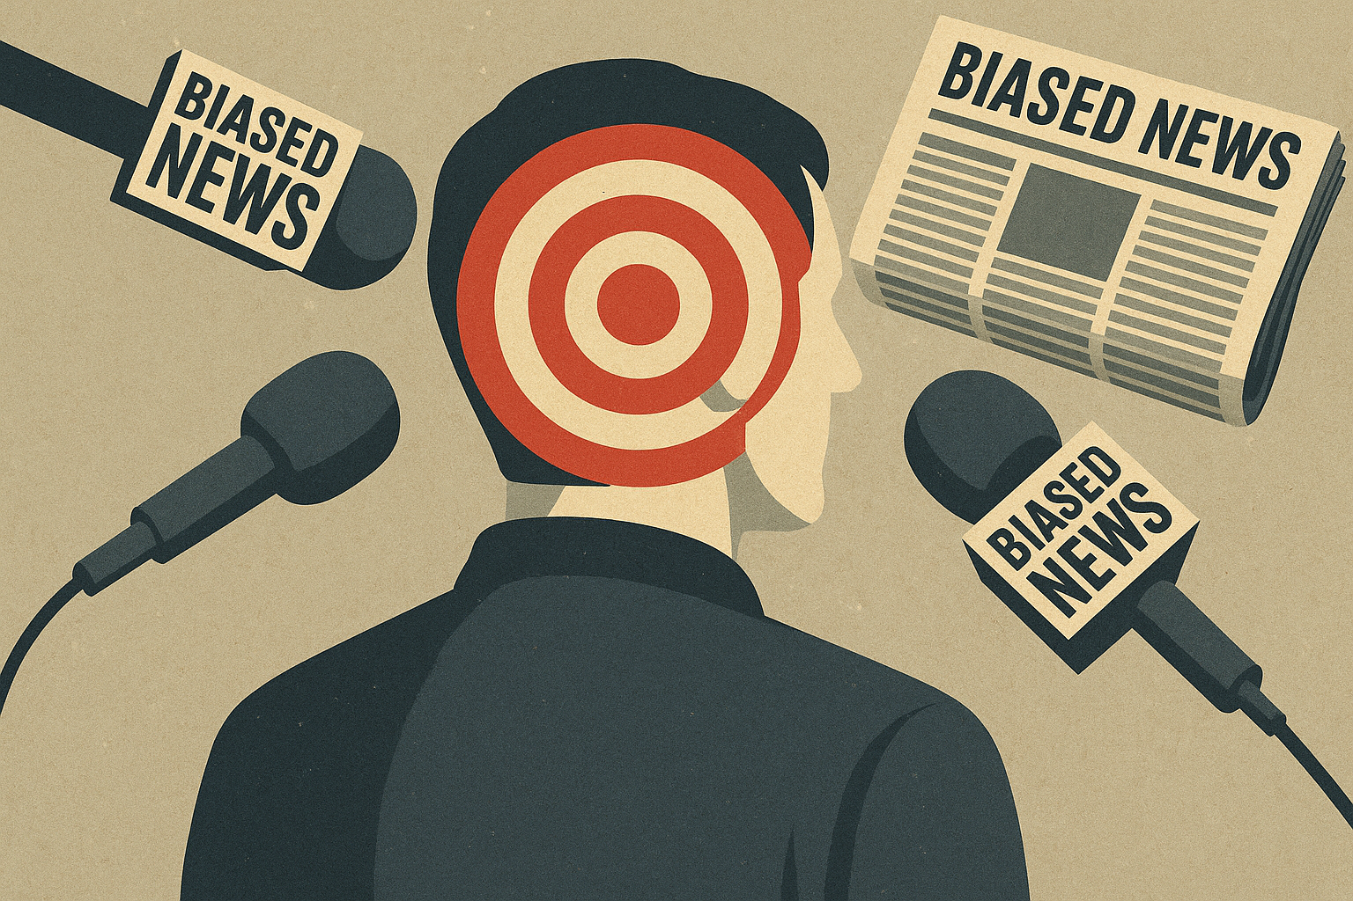

In terms of ethics:

This means manipulated empathy and care, responsibility without awareness, moral disengagement, erosion of moral autonomy, false consensus, and so much more.

Digital Consent Is Not Real Consent
In liberal democratic ethics, consent is a cornerstone: we believe people should freely choose what they believe, what they share, what they agree to.

But Chomsky would ask:
If your worldview is algorithmically tailored to keep you engaged (addicted),
If you are fed only certain kinds of content,
If you do not see the world as it is, but as someone wants you to see it…
…can you truly consent to anything?
Digital consent is too often manufactured consent—a performance of choice in a system of control.

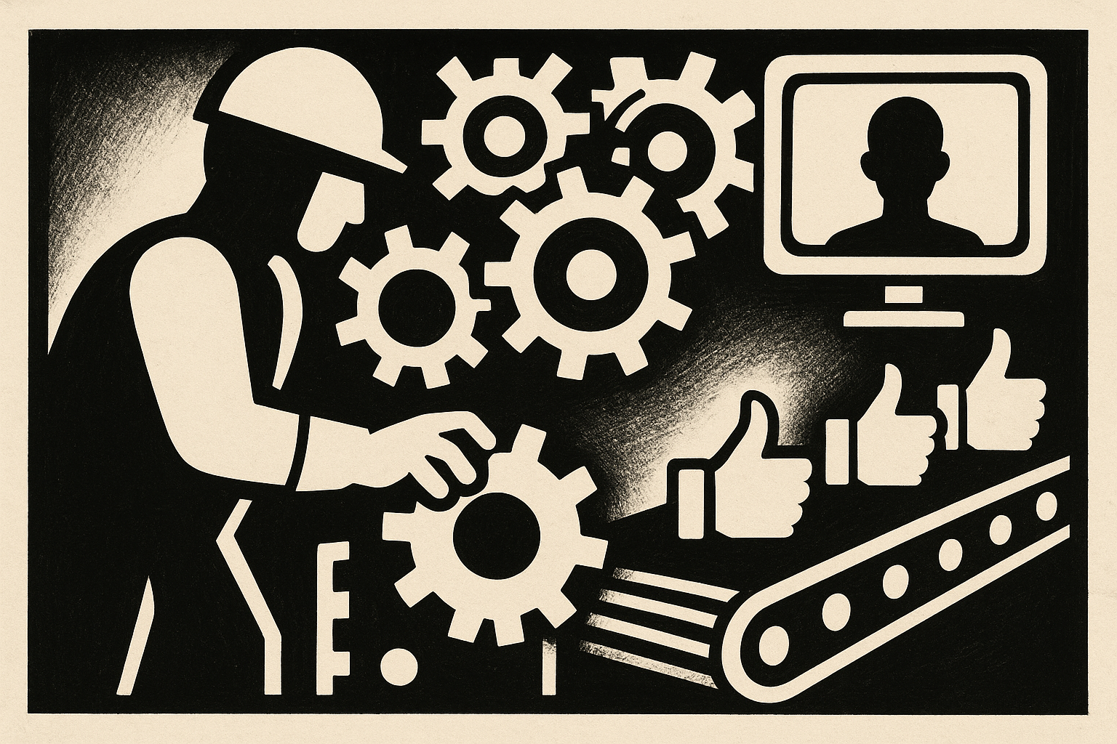

Key Ethical Questions in the Age of Information Control
Let’s ask ourselves:
- Am I really informed—or just entertained and influenced?
- Are my beliefs shaped by open inquiry—or by platforms designed for engagement and profit?
- When I’m critical, who benefits from my criticism?

Can ethics survive in a world where truth itself is fragmented, and distrust is a currency?
These questions strike at the heart of digital ethics.
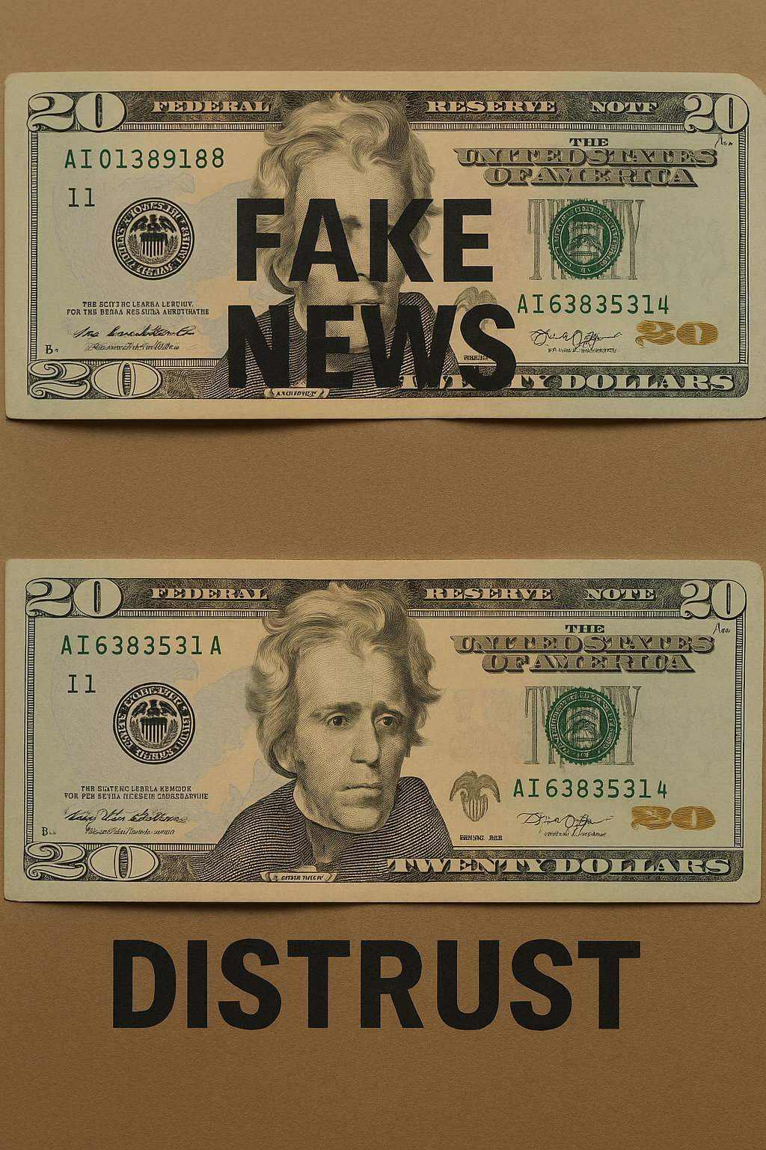

Freedom and Resistance: What Chomsky Demands of Us
Chomsky doesn’t just describe the problem. He offers a challenge:
- Don’t settle for feeling critical—demand access to unfiltered truth.
- Recognize the systems—corporate, political, technological—that shape your moral horizons.
- Develop ethical literacy, not just media literacy.
- Understand that your emotions, your outrage, your values, are shaped as much by how you receive information as by what the information is.
This is a call not only to think, but to understand how thinking itself is vulnerable.

Digital Ethics Today: Beyond Individual Responsibility
In the past, ethics focused on individual decision-making. Chomsky helps us see that this is not enough.
Ethics in the digital age must include:
- Structural critique of media systems and tech platforms
- Transparency about how data and content are manipulated
- Accountability for those who profit from misinformation and division
- Protection for truth-seeking individuals and dissenting voices
- Cultivation of communities that value context, nuance, and justice

The Central Question: Can We Think for Ourselves Anymore?
“What are we thinking critically about?”
Chomsky’s most provocative insight isn’t just that propaganda exists, but that it structures our perception of reality while making us believe we are free-thinking individuals.

In the Enlightenment tradition, we assume that education, science, and freedom of speech have made us more rational and less susceptible to ideological control than past generations.

But what if this belief in our own rational autonomy is the most powerful ideology of all?
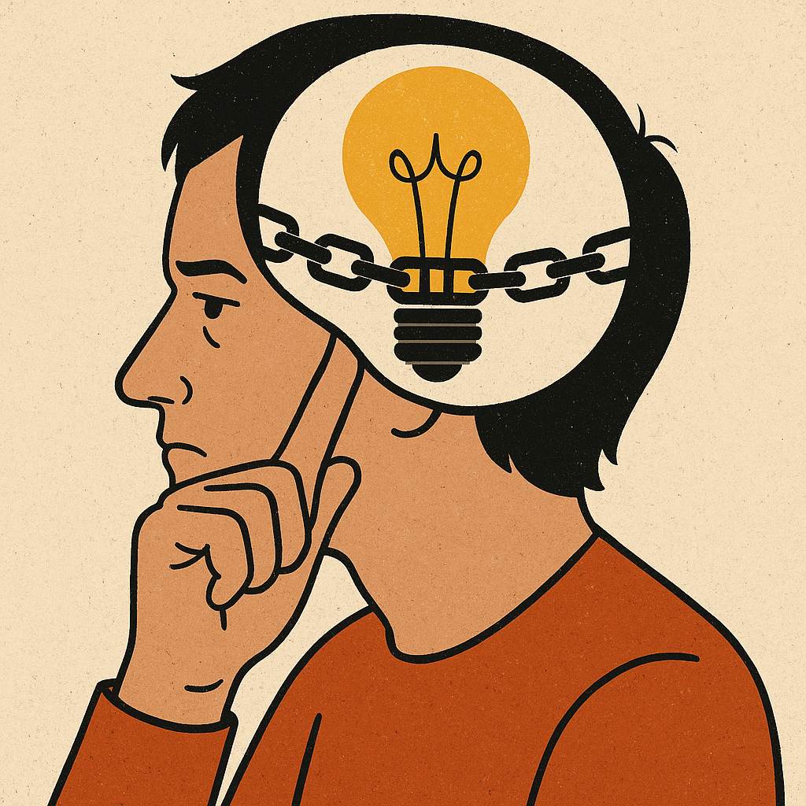

The Five Filters of Mass Media
Let us explore how ideology operates invisibly through the following five filters—and what that means in the age of digital capitalism.

1. Size and Concentration of Ownership
- Large corporate media outlets are owned by a few powerful entities, tightly interwoven with corporate and state interests.
- These media institutions share one overriding goal: maintain and grow capital.
This means:
- Promoting consumerism
- Undermining critique of elite power structures
- Protecting the status quo—including capitalism itself
Historical context:
- Media wasn’t always this centralized. In the early-to-mid 20th century, newspapers, radio stations, and local TV outlets were often family-owned, locally operated, or community-affiliated.
- Cities had multiple independent dailies, and ownership was more diverse in terms of geography, ideology, and accountability. This allowed for greater editorial independence—and at times, even open political rivalry between papers.
- That changed dramatically from the 1980s onward, as deregulation policies (such as the U.S. Telecommunications Act of 1996) facilitated massive mergers and acquisitions.
The result: today, a handful of multinational conglomerates—like Comcast, Disney, and News Corp—control the overwhelming majority of mainstream media in North America.

Concrete Example:
The Washington Post, owned by Amazon founder Jeff Bezos, has been criticized for its cautious coverage of Amazon labor disputes. Critics argue that coverage of warehouse working conditions or union efforts is often less prominent or more restrained compared to independent media. This raises uncomfortable questions about how ownership shapes what stories are told—and how.
Digital Update:
- The promise of the internet was decentralization—but the reality is an even more intense concentration.
- Today, a handful of digital platforms—Google (Alphabet), Meta (Facebook/Instagram), Amazon, Apple, and Microsoft—control the dominant infrastructures of global communication.
- These are not just media companies; they are gatekeepers of information flow, shaping what is visible, what is recommended, and what disappears.
- YouTube, owned by Google, determines what videos are promoted or demonetized.
- Facebook and Instagram (Meta) control the visibility of news and social content.
- Google Search influences what we “know” simply by ranking results.

Their algorithms are designed for profit and platform engagement—not truth, ethics, or civic well-being.

The concentration of power in digital media may now exceed that of any previous era of mass communication.

In a world where media and market are fused, what happens to independent thought?

2. Advertising
- Advertisers act as unofficial gatekeepers, determining which narratives are profitable and which ones are not.
- Media must attract not everyone, but audiences with buying power.
- As a result, media:
  - Targets wealthier, consumerist viewers
  - Avoids stories that challenge capitalism
  - Promotes “soft” or entertaining content over structural critique
Concrete Example:
In 2023, advertisers and platforms like YouTube pulled monetization from Russell Brand’s channels following public allegations of sexual misconduct—prior to any legal ruling. While some viewed this as a responsible precaution, others argued it revealed how advertising and public image—not legal due process or journalistic standards—now determine visibility and funding. The controversy exposed how fragile content sustainability is when it depends on corporate brand safety rather than editorial integrity.

Why avoiding controversy is ethically dangerous:
- When media avoids controversy to protect advertising revenue, it creates an environment where ethical reflection is suppressed.
- But ethics requires controversy: it asks us to confront uncomfortable truths, conflicting values, and difficult questions about justice, harm, and responsibility.
If media only promotes what is safe, agreeable, and ad-friendly:
- Structural injustices go unexamined
- Marginalized voices are filtered out
- Complex truths are replaced by clickbait simplicity

In such an environment, we are not being informed—we are being pacified. The ethical imagination is dulled, and dissent becomes impolite rather than necessary.

Ethical Journalism vs. Influencer Culture
Ethical journalism prioritizes:
- Verifying facts, even when inconvenient
- Exposing power structures
- Giving voice to those without institutional access
- Asking questions that advertisers would rather avoid

Examples
Positive: Investigative journalists at ProPublica or The Intercept have run major exposés on corporate lobbying, mass surveillance, and labor abuses—often with limited advertising support and ongoing threats to their funding models. These stories often upset powerful institutions, but they serve the public good by making injustice visible.
Influencer culture, by contrast, is structured around:
- Personal brand management
- Algorithmic popularity
- Sponsor-friendly content
- Avoidance of divisive topics

Negative Example:
A lifestyle influencer working with Nike or Sephora is unlikely to critique global labor conditions, even if their platform reaches millions. Their success depends on maintaining a pleasing, apolitical persona that won't jeopardize ad deals. The result? Enormous influence, but minimal ethical challenge.

Digital Update:
Online, algorithmic engagement and ad optimization dominate.
- Attention, not truth, is the currency.
- Popularity becomes a proxy for trustworthiness.
- The most visible content is not necessarily the most valuable—but the most viral.
Ethically speaking:
- What kind of citizen is produced by this environment?
- What kind of ethics can survive where truth is a side effect of engagement?

3. Sourcing
- Most news stories are sourced from press releases, government briefings, and corporate communication.
- Journalists rely on these sources because they are cost-effective, legally safe, and "official."
- These stories reinforce the authority of those already in power.

What is your source of truth by which to make ethical decisions?

Chomsky’s deeper point:
Noam Chomsky emphasizes that media reliance on official sources is not just a convenience—it’s a structural mechanism of control.
- In order to maintain credibility, access, and career viability, journalists must preserve relationships with powerful institutions: government offices, corporate PR teams, military spokespeople. This creates a system of voluntary compliance, where media professionals self-censor, not because they’re forced to, but because:
    - They need those sources to do their jobs
    - They fear being cut off, discredited, or excluded from key networks
    - The system rewards access and punishes confrontation
As Chomsky notes, journalists are often not even aware that this is happening.
- It’s not about malice—it’s about invisible professional incentives that favor establishment narratives.
In a 1998 interview with The Common Good (David Barsamian, ed.), Chomsky says:
The smart way to keep people passive and obedient is to strictly limit the spectrum of acceptable opinion, but allow very lively debate within that spectrum—even encourage the more critical and dissident views. That gives people the sense that there's free thinking going on, while all the time the presuppositions of the system are being reinforced by the limits put on the range of the debate.”
Concrete Example #1: Iraq War (2003)
In the lead-up to the Iraq War, mainstream outlets like The New York Times relied heavily on Pentagon briefings and anonymous U.S. intelligence sources to report on supposed weapons of mass destruction. These “official” claims were later shown to be false—but not before they helped manufacture public support for a war that killed hundreds of thousands. The media didn’t lie—they simply trusted the wrong sources, because they had no incentive to do otherwise.

Concrete Example #2: Trudeau and the Freedom Convoy (2022)
During the Canadian Freedom Convoy protests, much of the mainstream press echoed government framing that characterized all protestors as dangerous, racist, or extremists. While some extremist elements were present, later analysis revealed a broader and more complex set of grievances, including civil liberties concerns. The initial storylines came directly from government briefings and were repeated without critical investigation—because those sources were seen as “official” and legally safe.

Concrete Example #3: Corporate Greenwashing via Press Releases
Companies like ExxonMobil and BP routinely issue glossy press releases about their green initiatives, which are then reprinted or cited uncritically by business and tech media. Investigative reports often show these claims are exaggerated or deceptive. But because the press releases are well-packaged and “official,” they often escape critical scrutiny—especially in ad-driven environments where upsetting sponsors carries real risk.

Chilling Twist:
We pay taxes to fund government PR machines like the Pentagon or Public Safety Canada—and then the media simply repeats those talking points back to us, laundered through “neutral” reporting. We’re not just being informed—we’re being managed.

Digital variant:
AI-generated content is increasingly used by both corporations and governments.
- Press releases, briefings, and even full news stories are being drafted by algorithmic systems.
- Journalists, under-resourced and overworked, are incentivized to republish these materials with minimal fact-checking.
This raises a disturbing prospect:
What happens when both the source and the filter are AI systems built by the same power structure?
- Who verifies the verifiers?
- How do we trace truth in a world of synthetic sourcing?

4. Flak
- Flak refers not simply to criticism, but to organized, high-intensity responses—often backed by financial, institutional, or political power—aimed at discrediting or punishing media that challenges dominant interests.
- It can take the form of lawsuits, coordinated public relations campaigns, political pressure, advertiser withdrawal, or threats to access and professional reputation.
- Importantly, flak does not always need to succeed outright; its deterrent effect shapes editorial choices in advance.
    - Journalists and media organizations often pre-emptively adjust content to avoid backlash—not due to direct censorship, but because they understand the costs of provocation in a system where controversy can jeopardize access, funding, or credibility.
- As a result, self-censorship becomes systemic: not an act of cowardice, but a rational adaptation to a media environment structured by risk aversion and institutional dependency.

In Manufacturing Consent, Chomsky and Herman describe flak as one of the five key filters, defining it as:
“Negative responses to a media statement or program. It may take the form of letters, telegrams, phone calls, petitions, lawsuits, speeches and bills before Congress, and other modes of complaint, threat, and punitive action.”

- Crucially, Chomsky emphasizes that flak is not just spontaneous outrage—it is often organized, well-funded, and ideologically motivated.
- Its goal is not dialogue but discipline.
- It creates a climate of fear and professional caution, especially among journalists who must navigate high-stakes reputational terrain.

Digital Flak
Dimension | Chomsky’s Era | Digital Age
Source of flak | Elites (gov’t, corporations, think tanks) | Elites + users + algorithms + platforms
Mechanism | Lawsuits, ad withdrawal, public campaigns | Deplatforming, viral outrage, AI moderation
Speed | Slow, formal | Instant, viral, untraceable
Visibility | Institutional, documented | Opaque, algorithm-driven
Effect | Editorial caution | Self-censorship, invisibility

1. It is now both top-down (government, elites) and bottom-up
- Elite actors still deploy flak through legal threats, disinformation campaigns, or advertiser pressure (e.g., lobbying YouTube to demonetize a journalist).
- But now, mass flak can also emerge from social media users, forming digital mobs that pressure platforms and media companies into removal, apology, or retraction.
- This bottom-up flak is often algorithmically amplified, making it far more visible and emotionally charged.
2. It is faster, less traceable, and more chaotic
- In Chomsky’s time, flak had a paper trail—letters, lawsuits, formal denouncements.
- Today, a viral backlash can emerge in hours, often without clear leadership, making it harder to assess its origin or legitimacy.
- Corporate actors can also hide behind seemingly grassroots campaigns (astroturfing), giving the illusion of democratic criticism.
3. Flak now includes platform enforcement
- Platforms like Facebook, YouTube, and X (Twitter) enforce content rules driven not only by law, but by brand safety, algorithmic bias, and political pressure.
- Demonetization, shadow banning, and algorithmic suppression are new forms of flak—automated, opaque, and difficult to challenge.
- A journalist can now be punished not by a lawsuit, but by the platform quietly making their work invisible.
4. It exploits performative outrage
- Social media encourages outrage as performance, where users build identity and clout by joining digital dogpiles.
- This has led to a culture where even thoughtful dissent can be mischaracterized as extremism, prompting professional consequences without substantive critique.
5. It reinforces self-censorship—but in new ways
- As in Chomsky’s time, media workers today often self-censor in anticipation of backlash.
- But now the pressure comes not just from elite gatekeepers, but from algorithms, audience analytics, online mobs, and internal DEI or PR departments worried about brand image.
- Controversy is now a business liability—regardless of truth.

Concrete Example #1: Planet of the Humans (2020)
When Planet of the Humans—a documentary critical of green energy’s corporate entanglements—was released, it was met with overwhelming backlash from environmental NGOs, progressive media outlets, and corporate funders. YouTube temporarily removed the film, citing copyright concerns, and prominent environmental figures called for its suppression. Supporters argued that this flak proved the film’s thesis: even eco-conscious narratives are shaped by capitalist incentives and cannot tolerate internal critique.

Concrete Example #2: Glenn Greenwald and The Intercept (2020)
Investigative journalist Glenn Greenwald resigned from The Intercept, the outlet he co-founded, claiming that editors refused to publish his article critical of Joe Biden’s foreign policy ties unless he removed parts related to Hunter Biden. Greenwald alleged political interference masked as editorial oversight. While The Intercept denied the charge, the incident sparked debate about whether ideological flak—from donors, readers, or internal politics—was influencing editorial decisions. The controversy illustrates how ideological discipline can operate even inside ostensibly independent outlets.

Concrete Example #3: Julian Assange and WikiLeaks
After publishing classified documents exposing U.S. war crimes, WikiLeaks and founder Julian Assange were subjected to a massive campaign of legal and reputational flak:
- Smear campaigns in major newspapers
- Accusations of espionage
- Deplatforming from PayPal, Visa, and MasterCard
- A prolonged legal battle that has included extradition attempts and imprisonment

Whether one supports or opposes Assange, the scale and intensity of the backlash shows how threatening dissent—especially against military power—can provoke institutional punishment disguised as justice.

Modern forms of flak:
- Social media dogpiles orchestrated by political actors or brand-conscious audiences
- Demonetization or shadow banning for controversial content—even if not false or harmful
- Corporate PR backlash threatening to withdraw advertising from platforms hosting dissent
- Think tanks and advocacy groups like The Media Research Center, Accuracy in Media, or The Media Institute—which present themselves as neutral arbiters of “bias” while advancing political agendas

The illusion of objectivity:
- The more a source brands itself as “fair,” “balanced,” or “apolitical,” the more critical we must be.
- Whose interests does it serve?
- Who funds its silence?
- What backlash does it fear most?

As Chomsky notes, media control today does not require overt censorship.
It only requires making dissent expensive.

Chomsky and Herman write:

“If you want to have a career in the media... you have to serve the interests of the people who own and control the media. And that’s not a conspiracy—it’s just market forces at work.”

Also, in a famous exchange with Andrew Marr (BBC), Chomsky says:

“I’m not saying you're self-censoring. I'm sure you believe everything you're saying. But what I’m saying is that if you believed something different, you wouldn’t be sitting where you’re sitting.”

5. Anti-Communism / Dichotomization
- Chomsky emphasizes that the purpose of this filter is not to clarify truth but to dichotomize the world into worthy and unworthy victims—where suffering, violence, or injustice are only highlighted if they occur within groups friendly to dominant political interests.

The filter:
- Encourages loyalty-based moral reasoning rather than principle-based analysis
- Frames dissent as dangerous, disloyal, or morally suspect
- Creates ideological immunity: once a label is applied—terrorist, traitor, extremist, Marxist—no further investigation is needed. Debate is closed. Judgment is pre-decided.

Concrete Example: Student Protest Dichotomization (2023)
After the October 2023 Hamas-Israel conflict, university protests in the U.S., Canada, and the UK—many focused on Palestinian civilian deaths and ceasefire advocacy—were rapidly labeled as “pro-terrorist,” “antisemitic,” or “hate-based.”

This framing was:
- Often applied regardless of the actual content of the protest
- Used by politicians, university administrators, and major media outlets
- Amplified by social media campaigns, sometimes using bots or anonymous amplification tools

The binary logic of “pro-Israel = moral” and “pro-Palestinian = extremist” collapsed complex political and ethical questions into moral panic.
- Students, faculty, and journalists faced threats, firings, and deplatforming—not for hate speech, but for expressing unpopular or controversial views.

- This is not a defense of all protest rhetoric—but a critique of the reflex to collapse all critique into complicity with evil. That’s precisely what this filter enables.

Digital amplification:
In the digital age, dichotomization is hypercharged by platform dynamics:
- Algorithms reward outrage, simplicity, and moral certainty
- Social media encourages performative identity alignment: your stance on one issue becomes shorthand for your entire moral worth
- People are not only judged—but sorted, flagged, and punished—based on a single post, hashtag, or affiliation

Ethical consequences:
- We are trained to ask: “Which side are you on?” rather than “What is just? What is true?”
- We judge people not by their reasoning or values, but by labels and affiliations
- We lose the capacity for nuanced moral judgment, empathy, or solidarity across ideological lines
- As Chomsky might frame it, this is not just a distortion of media—it is a distortion of democracy itself.

Filtering as a Metaphor for Digital Ethics
- There is no such thing as unfiltered information.
- Every system has its own filters—whether they are capitalist, ideological, algorithmic, or emotional.

Chomsky’s question in the digital age becomes:
What kind of filters would a free society build?

Should we want:
- Filters that prioritize truth over profit?
- Filters that protect minority voices instead of amplifying the powerful?
- Filters that reward critical engagement, not emotional manipulation?

In a world where platforms, politics, and profit are indistinguishable, ethical media literacy is a survival skill.

The Media Landscape Today

The media landscape today appears more decentralized on the surface, but in reality, it is even more consolidated than it was when Chomsky wrote Manufacturing Consent.

Here's how and why:

1. Fewer Gatekeepers, Greater Control

In Chomsky's era, media was concentrated in the hands of a few major content producers (TV networks, newspapers). Today, a handful of tech giants control the distribution of nearly all information—giving them unprecedented influence over what people see, share, and believe.

The New Gatekeepers:
- Google (Alphabet) – Dominates search and YouTube.
- Meta (Facebook, Instagram, Threads, WhatsApp) – Controls social discovery and news sharing for billions.
- Apple – Filters access through the App Store and Apple News.
- Amazon – Controls web infrastructure (AWS), content (Prime), and e-books (Kindle).
- TikTok (ByteDance) – Drives algorithmic news exposure for a massive younger demographic.
- X (formerly Twitter) – Remains a key political and journalistic platform despite chaotic governance.

These companies act as chokepoints, determining which “voices” and platforms get algorithmic visibility.

2. Algorithmic Filtering Is the New Censorship

What Chomsky called editorial filters are now algorithmic filters—and these are:
- Opaque – Users don’t know how information is ranked or suppressed.
- Behavioral – Optimized for engagement, not truth or fairness.
- Self-reinforcing – Personalized feeds insulate users in filter bubbles, making ideological escape difficult.

So even though more people can “publish,” only content that aligns with platform incentives (outrage, conformity, virality) tends to survive.

3. The Myth of Diversity

The abundance of content sources gives the illusion of pluralism. But:
- Many “independent” sources are derivative (reposting wire stories or echoing dominant narratives).
- Small outlets rely on the visibility granted (or denied) by the platform monopolies.
- What goes viral is not what’s most informative—it’s what best fits the algorithm.

In effect, more voices exist, but fewer entities decide which voices are heard.

4. Hyper-Consolidated Influence

In the 1980s, six corporations owned most U.S. media. Today, just a few tech companies dominate global discourse—across nations, languages, and ideologies.

This is arguably worse than the situation Chomsky described:

Then: corporate media filtered news to align with elite U.S. economic and political interests.

Now: platforms monetize attention, regardless of truth, ethics, or public interest.

Conclusion

The number of content creators has exploded. But the number of distributors with real power has shrunk.
- These tech giants don’t just manufacture consent; they manufacture reality by controlling access to information, shaping social behavior, and determining the terms of public discourse.
- The problem isn't decentralization—it's concentrated control disguised as decentralization.

SECTION TWO – Documentary: Manufacturing Consent and the Structure of Digital Illusion

🎬 Watch: Noam Chomsky – Manufacturing Consent (Documentary)
🕐 Total Runtime: 50 minutes
⚠️ Warning: Very Graphic Content
Note: You will NOT be tested on this content. It is meant for educational purposes only.

What Is Democracy Based On Today?
Philosophers like Plato and Aristotle envisioned democracy as a system that:
- Embodied reason,
- Encouraged human flourishing, and
- Served the common good.
But Chomsky flips that ideal upside down.
For Chomsky, democracy today doesn’t depend on reason.
It depends on ignorance, apathy, and consent that has been manufactured.
We believe we are free, rational thinkers in a democratic society.
But Chomsky asks:
- Do we actually seek truth?
- Or are we obedient to power, emotion, and illusion?

The Core Claim
“Indoctrination is the essence of democracy.” — Chomsky
- We are told that truth, transparency, and accountability matter.
- But when media, business, and politics work together, their real interest is control.
- This is not a conspiracy—it is a system.
A system in which you are encouraged to believe you're thinking freely, even as you're being manipulated.

Case Study: Genocide and Media Silence
Chomsky compares two atrocities that happened at nearly the same time:

1. Cambodia under Pol Pot (Khmer Rouge)
- Widely publicized in the West
- Framed as a horrific failure of communism

2. East Timor under Indonesian invasion (1975–1999)
- Western-backed genocide
- Canada, the US, and others profited from selling weapons to Indonesia
- Result: Ignored or underreported by Western media

Ask yourself:
- Have you heard of Pol Pot? Likely, yes.
- Have you heard of the East Timor genocide? Probably not.
- Why?
Chomsky literally measured column inches of media coverage—Cambodia was front-page news, East Timor was a ghost.

The Ethical Point
One genocide is useful for shaping public opinion; the other is inconvenient to power.
This isn't just bias. It is systematic silence, shaped by:
- National interest
- Corporate profit
- Control of narrative
And once again, advertising, sourcing, and flak all played a role.

Implications for Today: The Digital Mirror

In Chomsky’s day:
Media was paper-based, slow, and centralized.

Today:
We live in a digital ecosystem of constant exposure, curated by:
- Algorithms
- Platform incentives
- Engagement metrics
- Data-driven emotional manipulation

Ask yourself:
- What isn't showing up in your feed?
- What isn't trending—and why?
- How do we know when silence is strategic?

Digital Filters: Do They Still Apply?
Chomsky’s Five Filters (ownership, ads, sources, flak, dichotomization) still apply, but now with added speed, scale, and automation:
Filter | Digital Form
Ownership | Big Tech monopolies (Meta, Alphabet, X)
Advertising | Surveillance capitalism & algorithmic targeting
Sourcing | Influencer PR, AI-written news, branded content
Flak | Social media dogpiles, demonetization, cancel culture
Dichotomy | Culture wars, “us vs them,” echo chambers

Modern Questions We Must Ask
- How does Facebook (or TikTok or YouTube) shape what I believe?
  - What content is boosted, and what is buried?
- Are these platforms extensions of state and corporate power?
  - Who gets silenced? Who gets amplified?
- What is my ethical responsibility as a digital citizen?
  - Do I challenge the narrative—or just consume?
- What truths are left out because they aren’t profitable?
- If democracy is built on participation, can we say we live in a democracy if what we participate in is pre-filtered?

Conclusion: Chomsky’s Digital Warning
“The real illusion is that you are free. The real job is not to think—but to obey.”
Chomsky challenges us to recognize that freedom of thought requires more than free speech.
It requires:
- Control of information
- Critical awareness of power
- And the ability to recognize ideology even when it flatters us
In the digital age, propaganda is frictionless, news is gamified, and truth is a design decision.

